
SRM Institute of Science and Technology
SET C
College of Engineering and Technology
School of Computing
SRM Nagar, Kattankulathur – 603203, Chengalpattu District, Tamilnadu
Academic Year: 2022-23 (EVEN)
Test: CLA-T2 Date: 29-03-2023
Course Code & Title: 18CSC204J Design and Analysis of Algorithms Duration: 1 hour 40 min
Year & Sem: II Year / IV Sem Max. Marks: 50

Course Articulation Matrix: (to be placed)
Course Outcome | PO1 | PO2 | PO3 | PO4 | PO5 | PO6 | PO7 | PO8 | PO9 | PO10 | PO11 | PO12
CO1 | 2 | 3 | - | - | - | - | - | - | - | - | - | -
CO2 | - | 3 | 2 | - | - | - | - | - | - | - | - | -
CO3 | - | 3 | 3 | - | - | - | - | - | - | - | - | -
CO4 | 3 | 2 | 3 | - | - | - | - | - | - | - | - | -
CO5 | 2 | 3 | - | - | - | - | - | - | - | - | - | -

Part - A
(10 x 1 = 10 Marks)
Instructions: Answer all
Q. No | Question | Marks | BL | CO | PO | PI Code
1 | The algorithm which has time complexity of O (n log n) for best, worst, and average cases is  - Merge sort  - Quick sort  - Insertion sort  - Selection sort | 1 | L1 | 2 | 2 | 2.5.2
2 | Time complexity of Strassen’s matrix multiplication problem is:  - 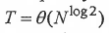  - 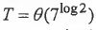  - 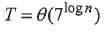  - 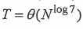 | 1 | L2 | 2 | 2 | 2.6.3
3 | The recurrence relation for finding maximum and minimum elements from an array using divide and conquer technique is T(n) =  - 2T(n/2) + n  - 4T(n/2) + n^2  - 2T(n/2) + 2  - 3T(n/2) + 1 | 1 | L2 | 2 | 2 | 2.6.3
4 | The most important condition for which closest pair is calculated for the points (pi, pj) is?  - i>j  - i=j  - i<j  - i!=j | 1 | L2 | 2 | 2 | 2.5.2
5 | A subset S of the plane is called convex if and only if  - For any pair of points p,q in S, the line segments pq is partially contained in S  - For any pair of points p,q in S, the line segments pq is contained outside S  - For any pair of points p,q in S, the line segments pq is not contained in S  - For any pair of points p,q in S, the line segments pq is completely contained in S | 1 | L1 | 2 | 2 | 2.5.2
6 | What is the time complexity of Huffman Coding?  - O(n³)  - O(n)  - O(nlogn)  - O(n²) | 1 | L1 | 3 | 2 | 2.5.2
7 | Which of the following is solved using dynamic programming?  - Fractional knapsack problem  - Longest common subsequence  - Huffman coding  - Binary search | 1 | L2 | 3 | 2 | 2.5.2
8 | The number of edges for a minimum cost spanning tree with n vertices of Graph G is  - n  - n-1  - n+1  - 2n | 1 | L3 | 3 | 2 | 2.6.3
9 | What is the time complexity of 0/1 knapsack problem in Dynamic Programming?  - O (n W)  - O(n)  - O(W)  - O (log n) | 1 | L1 | 3 | 2 | 2.5.2
10 | Let X = ABAADBAAB and Y = AADAAB The Longest Common Subsequence, Z, of X and Y is  - Z = DAB  - Z = AAB  - Z = AADAAB  - Z = ABADABAAB | 1 | L3 | 3 | 2 | 2.6.3
Part – B
(4 x 4 = 16 Marks)
Instructions: Answer ANY 4 Questions

16 | Find the time complexity of the following recurrence relations through proper steps of master’s theorem.  - T(n)=4T(n/4) +1 (2 Marks)  - T(n)=4T(n/2) + n. (2 Marks) | 4 | L3 | 2 | 3 | 3.6.2
17 | Write the recurrence relation for finding convex hull and derive its time complexity.  T(n) = 2T(n/2) + O(n) + O(1) ------- (2)  2T(n/2) – computing convex hull  O(n) – merging  O(1) – dividing two half  Master’s theorem  a=2, b=2, k=1, p=0  Time complexity : O(nlogn) ----------(2) | 4 | L3 | 2 | 3 | 3.6.2
18 | Imagine a binary search tree with the following integer values: 17, 28, 25, 51, 98, 55, 42, 37. Use tree traversal method which is useful to get the postfix expression of an expression tree.  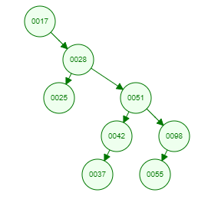  Postfix: 25, 37, 42, 55,98,51,28,17 | 4 | L3 | 3 | 2 | 2.6.3
19 | Provide the Pseudocode for a compression algorithm based on a greedy technique that uses binary trees and priority queues and allow the user to compress and decompress files using variable length codeword. Determine the number of bits to be transmitted for the following data and decode the code 110001101.  12x1 + 20x3+ 5x4 + 10x4 + 11x3 + 12x3 = 201 bits  Answer: CAD | 4 | L3 | 3 | 2 | 2.5.2
  Character | a | b | c | d | e | f
  Frequency | 12 | 20 | 5 | 10 | 11 | 12
  Code | 0 | 111 | 1100 | 1101 | 100 | 101
20 | Consider two strings X= “PQRSTPQRS” and Y= “PRATPBRQRPS”. Apply a dynamic programming technique to determine the longest common subsequence with the appropriate Pseudocode with its time complexity.  PRTPQRS | 4 | L3 | 3 | 2 | 2.6.4
Part – C
(2 x 12 = 24 Marks)
Instructions: Answer Two Questions
21 | You are designing a real-time system for processing online transactions. Each transaction is represented by a large amount of data, and you need to sort the transactions quickly to identify fraudulent ones. You decide to use a sorting algorithm that employs a pivot element. However, the system is resource-constrained, and you need to optimize the sorting algorithm for maximum efficiency. Apply a divide and conquer algorithm that selects the pivot element as the first element to ensure that the algorithm sorts the transactions as quickly as possible. Also provide the pseudocode with its time complexity analysis to your manager for approval.  Sample data: 23 12 45 34 67 78 54 8  Example: (5 Marks)  Algorithm: (5 Marks)  quickSort(arr[], low, high) {  if (low < high) {  /* pi is partitioning index, arr[pi] is now at right place */  pi = partition(arr, low, high);  quickSort(arr, low, pi – 1); // Before pi  quickSort(arr, pi + 1, high); // After pi  Time complexity: (2 Marks)  T(n) = T(k) + T(n-k-1) + (n)  O(nlogn) | 12 | L3 | 2 | 3 | 3.6.2
or |  |  |  |  |  |  |  | or
22 | A final year mechanical engineering student is designing a navigation system for a fleet of delivery drones. The drones need to avoid collisions with each other while flying to their respective destinations. She wants to detect and avoid collisions between closest drones and to alert their pilots to take evasive action. Assume that the fleet consists of thousands of drones and their locations are constantly updated in real-time with 2D plane, XY coordinates. What algorithm would you suggest the designer to solve this problem efficiently and accurately? Provide him the algorithm proposal in Detail with its time complexity analysis.  Algorithm : (7 Marks)  Begin  if n <= 3, then  call findMinDist(xSorted, n)  return the result  mid := n/2  midpoint := xSorted[mid]  define two sub lists of points to separate points along vertical line.  the sub lists are, ySortedLeft and ySortedRight  leftDist := findClosest(xSorted, ySortedLeft, mid) //find left distance  rightDist := findClosest(xSorted, ySortedRight, n - mid) //find right distance  dist := minimum of leftDist and rightDist  make strip of points  j := 0  for i := 0 to n-1, do  if difference of ySorted[i].x and midPoint.x<dist, then  strip[j] := ySorted[i]  j := j+1  done  close := stripClose(strip, j, dist)  return minimum of close and dist  End  Time complexity Analysis: (5 Marks)  T(n) = 2T(n/2) + O(n) + O(nLogn) + O(n)  T(n) = 2T(n/2) + O(nLogn)  T(n) = T(n x Logn x Logn)  Auxiliary Space: O (log n) | 12 | L3 | 2 | 3 | 3.6.2
23 | A telecommunications company is laying cable to a new neighborhood. If it is constrained to bury the cable only along certain paths (e.g., along roads), then there would be a graph representing which points are connected by those paths. Some of those paths might be more expensive, because they are longer, or require the cable to be buried deeper; these paths would be represented by edges with larger weights. Apply a greedy based algorithm for building a network where we want to select a subset of those paths that will make our network connected at the lowest cost. Determine a spanning tree for that graph that has no cycles but still connects to every neighborhood which would represent the least expensive path for laying the cable.  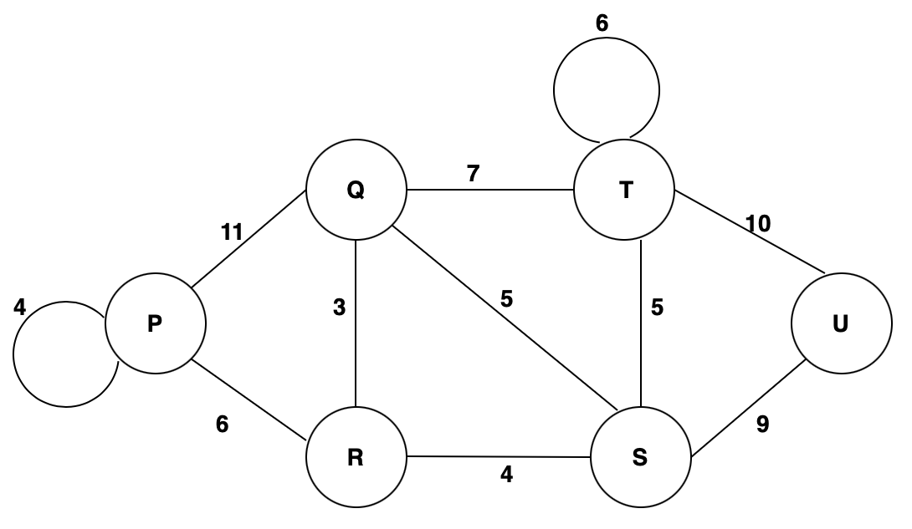  Pseudocode: (6 Marks)  Example (with steps): (6 Marks) | 12 | L3 | 2 | 3 | 3.6.2
or |  |  |  |  |  |  |  | or
24 | Describe a method that is extremely useful in dictionary searches. Consider the scenario where we translate the book from English to German, we look up equivalent words in the English-German dictionary and replace them in the translation. Words such as do, for, if and while are to be searched in the same manner as in binary search tree order. The likelihood of searching varies depending on the word whose successful search is given by {2,3,1,1} and unsuccessful search is given by {2,3,1,1,1}. Apply a dynamic programming technique with appropriate pseudocode to construct an efficient search tree for the given set of words.  Pseudocode: (6 Marks)  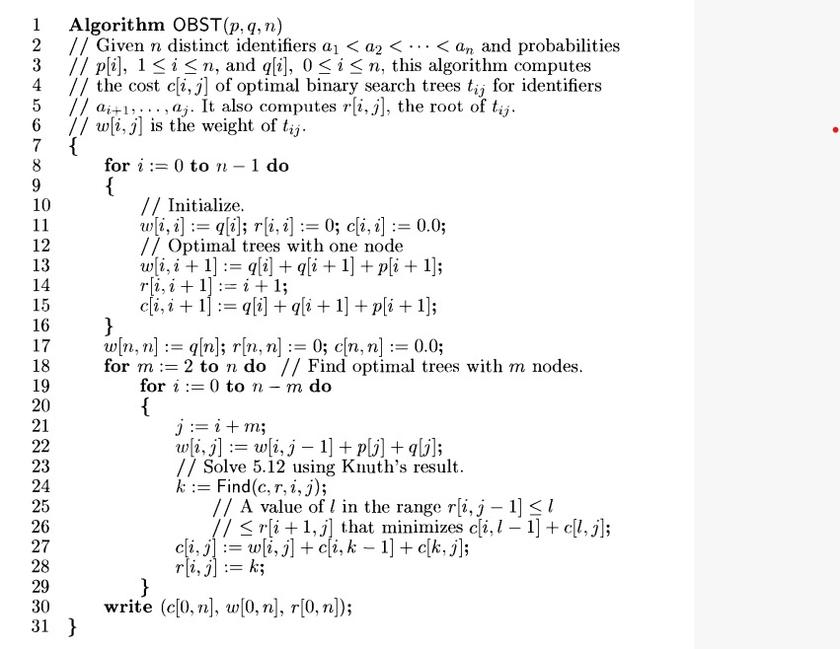  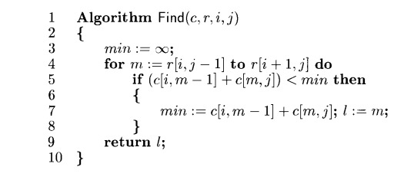  Example (with steps): (6 Marks)  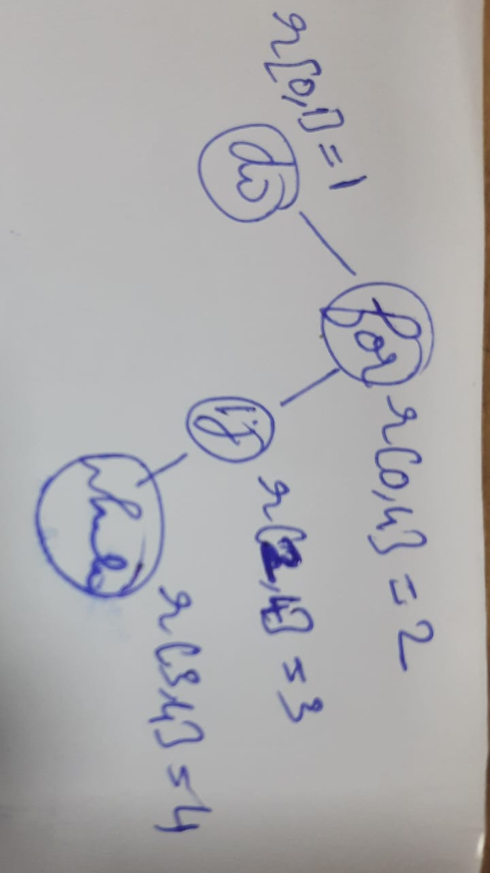 | 12 | L3 | 2 | 3 | 3.6.2

*Program Indicators are available separately for Computer Science and Engineering in AICTE examination reforms policy.

Course Outcome (CO) and Bloom’s level (BL) Coverage in Questions

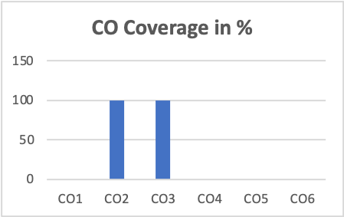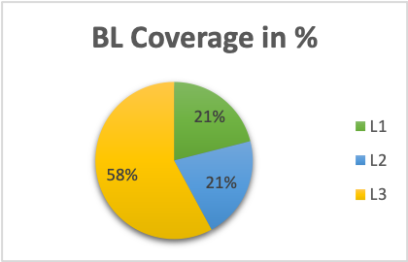

Approved by the Audit Professor/Course Coordinator

